

T E A C H I N G

P R O F E S S ION

A S A

**Mrs. Love**



**Description:** The practicum offers a candidate in the Teaching as a Profession career pathway a field experience under the direct supervision of a certified teacher (mentor teacher). The practicum stresses observing, analyzing and classifying activities of the mentor teacher and comparing personal traits with those of successful teachers. The candidate intern will develop a portfolio of their skills, plan and teach a lesson or lessons, understand and practice confidentiality as it pertains to the teaching profession, meet the needs of students with special needs, maintain the safety of the students, practice professionalism, and demonstrate ethical behavior.

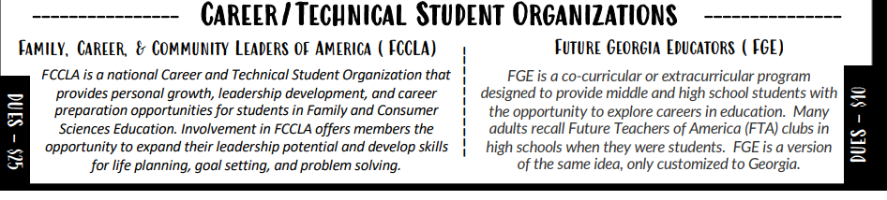

***Dues- $5***

*\*Mandatory for this course\**



Unit 1: Portfolio Preparation

Unit 2: Communication

Unit 3: Legal Issues in the Public

School Setting

Unit 4: Teaching Strategies

Unit 5: Classroom Management

Unit 6: Lesson Planning

Unit 7: Candidate Evaluation

Unit 8: EOPA



Email: adkinsta1@richmond.k12.ga.us

Class Website:

Phone: (706) 796-4924

Office Hours: Thursdays 3:00 pm - 4:00 pm

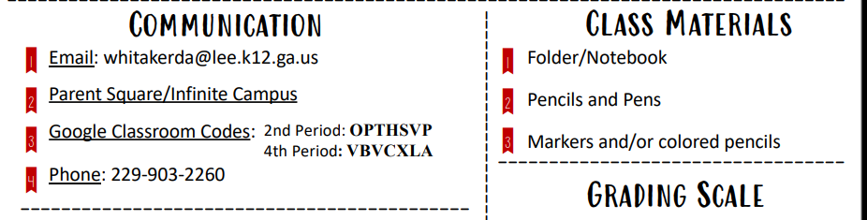

Email: adkinsta1@richmond.k12.ga.us

Class Website:

Phone: (706) 796-4924

Office Hours: (Room 115) Mondays & Tuesdays 2:30 pm - 3:30 pm



Email: lovebr1@richmond.k12.ga.us

Class Website: https://www.rcboe.org/Page/93938

Phone: (706) 868-4030

Office Hours: (Room B236) Mondays & Tuesdays 2:30 pm - 3:30 pm



Class Notebook/ Laptop

Pens/Pencils

Colored Pencils/ Highlighters

Index Cards



1st Offense – Verbal Warning

2nd Offense – After School Detention

3rd Offense – Parent Contact

4th Offense – Office Referral







Arrive to class on time, prepared, and ready to learn

Submit your best work in a timely manner

Be courteous, kind, and respectful

Challenge yourself to continuously improve



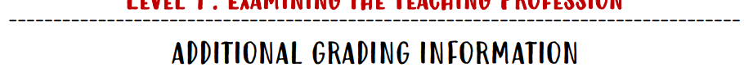

**Major: 40% Minor: 60%**



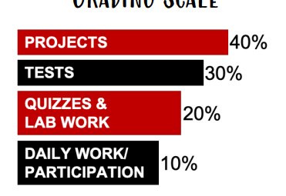

**(Major)**

A- 90-100

B- 80-89

C- 75-79

D- 74-70

F- Below 70

NC- No Credit

**(Major)**

**(Minor)**

**LATE WORK WILL BE ACCEPTED FOR UP TO 2 WEEKS AFTER THE DUE DATE FOR PARTIAL CREDIT**

**(Minor)**



This pathway is intended for students who are interested in careers in the Education field. Students are expected to uphold a professional standard as a future educator. This includes participating in professional dress days, confidentiality agreements, applications, case studies, being well prepared for class daily and being actively engaged during class. Attendance and behavior must also remain consistent and professional. Failure to do so could result in dismissal from this pathway.

**NEW POLICY:** No cell phone use will be permitted inside of the school or classroom.



Additional time is granted for work completion to students who are absent. Students have five (5) school days in which to complete and turn in any missed work.

*Students will have other guidelines and policies to follow in addition to the policies outlined in this syllabus, as it pertains to their individual practicum.

**Teaching as a Profession Practicum Syllabus Student & Parent Acknowledgement**

I have read and understood the syllabus in its entirety. I have asked questions about anything for which I want clarification.

Student’s Name: ___________________________________

Student’s Signature: ________________________________

Guardian’s Signature: _______________________________

Guardian’s email address: ___________________________

Please circle your preferred method of contact: email phone call note

*\*I make every effort to respond to email within 24 hours, please follow up with a phone call to the school if you do not hear from me.\**

Please list any additional information you would like me to know about your student so that he/she may have the best possible year. ____________________________________________________________________________________________________________________________________________________________________________________________________________________________________________________________________________________

